**DAILY ONLINE ACTIVITIES SUMMARY**

|  |  |  |  |  |  |  |  |  |
| --- | --- | --- | --- | --- | --- | --- | --- | --- |
| **Date:** | **7/6/2020** | | | | | **Name:** | **PONICA.J** | |
| **Sem & Sec** | **4TH & B** | | | | | **USN:** | **4AL18CS055** | |
| **Online Test Summary** | | | | | | | | |
| **Subject** | | **-** | | | | | | |
| **Max. Marks** | | **-** | | **Score** | | | **-** | |
| **Certification Course Summary** | | | | | | | | |
| **Course** | **INTRO OF PYTHON** | | | | | | | |
| **Certificate Provider** | | | **UDEMY** | | **Duration** | | | **5 HOURS** |
| **Coding Challenges** | | | | | | | | |
| **Problem Statement:** | | | | | | | | |
| **Status:EXECUTED** | | | | | | | | |
| **Uploaded the report in Github** | | | | | **YES** | | | |
| **If yes Repository name** | | | | |  | | | |
| **Uploaded the report in slack** | | | | | **YES** | | | |

Online Test Details: (Attach the snapshot and briefly write the report for the same)

Certification Course Details: (Attach the snapshot and briefly write the report for the same)

I CHOOSED INTORDUCTION TO PYTHON PROGRAMMING AND IT IS OF 5 HOURS COURSE .I HAVE ATTACHED THE SNAPSHOT OF MY COURSE BELOW .

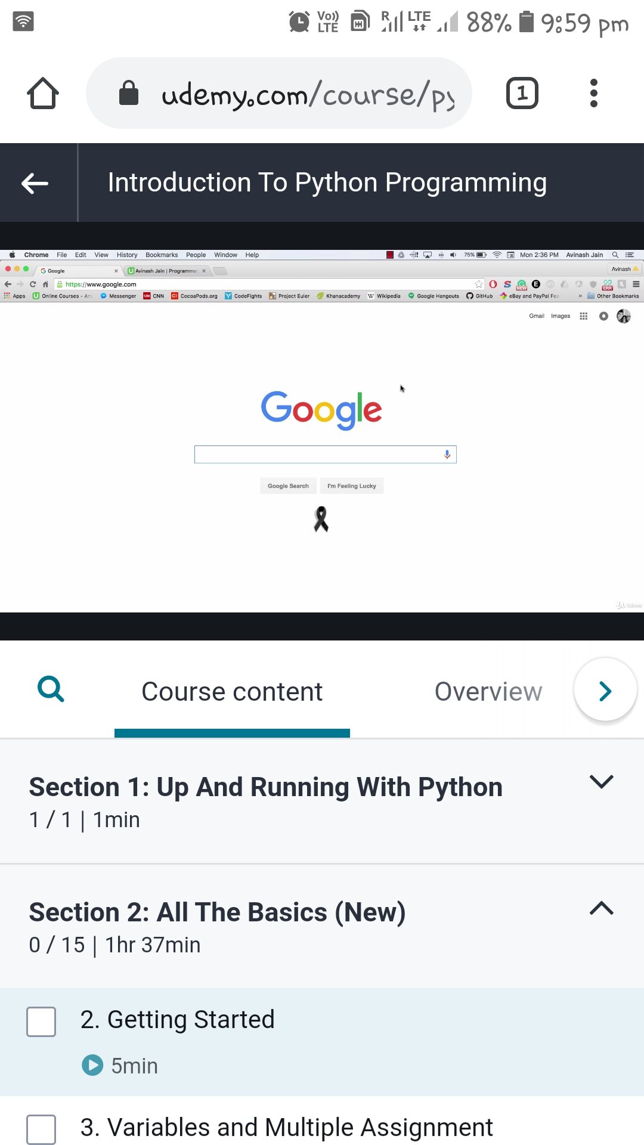

Coding Challenges Details: (Attach the snapshot and briefly write the report for the same)

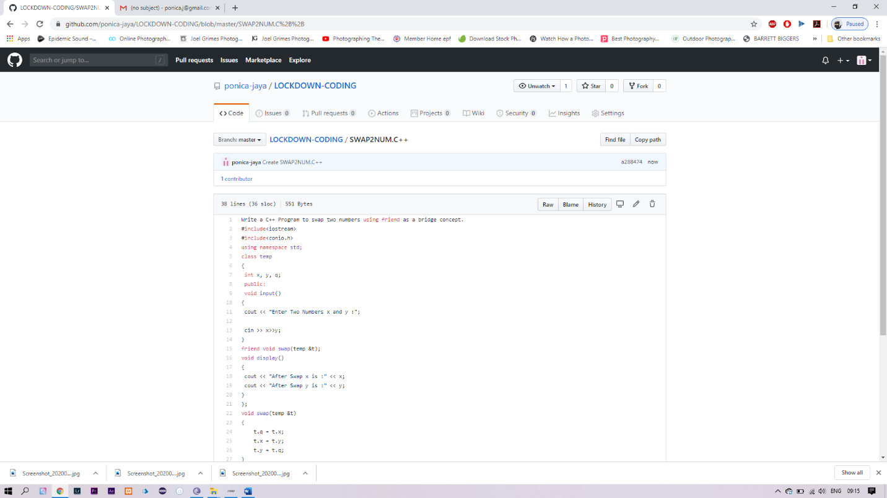

I HAVE GOT THIS PROBLEM I HAVE SOLVED IT AND UPLOADED IT IN GITHUB